Outline of Evaluation Workbench
(First Approximation)
7/8/2011

Setup

Startup parameters are listed in the “startup.properties” file, and include the names of the two annotators to be compared, and the directory containing annotation files and documents. E.g.,

sourceDirectory=/Users/leechristensen/Desktop/Shiga Results JESS
firstAnnotator=primary
secondAnnotator=secondary

(My experimental annotation set includes two identical sets of files, automatically generated by our new version of Topaz under development.)

Both annotation xml files and report files are contained in the sourceDirectory. Each annotation file specifies the name of its corresponding report file, and contains annotation information including classification, attributes and relations. Names of annotation files must end in “.xml”. Annotation specifications contain a unique id, level, classification, attributes, spans and relations to other annotations, e.g.

…
<annotation id="DocumentAnnotation_3" level="DocumentAnnotation">
<classification name="vomiting"/>
<attributes>
<attribute name="state" value="acute"/>
<attribute name="cui" value="C0042963"/>
</attributes>
<relations>
<relation name="component_of" value="SnippetAnnotation_4"/>
<relation name="component_of" value="SnippetAnnotation_5"/>
</relations>
<spans>
<span start="2320" end="2327" text="vomiting"/>
<span start="10183" end="10190" text="vomiting"/>
</spans>
</annotation>
<annotation id="SnippetAnnotation_4" level="SnippetAnnotation">
<classification name="vomiting"/>
<attributes>
<attribute name="concept" value="vomiting"/>
<attribute name="temporality" value="acute"/>
<attribute name="cui" value="C0042963"/>
<attribute name="directionality" value="affirmed"/>
<attribute name="experiencer" value="patient"/>
</attributes>
<relations>
</relations>
<spans>
<span start="2320" end="2327" text="vomiting"/>
</spans>
</annotation>
…

GUI

The workbench GUI consists of three windows: Document pane (left), Class/Statistics pane (upper right), and Reports, Attributes and Relations panes (lower right). There is a currently selected clinical report , annotator (here called “primary” or “secondary”), annotation model level (in this set, either Document or Snippet), and annotation object. These items are displayed in the title bar. The classification of the selected annotation is highlighted in the class/statistics pane, and the attribute and relation panels display attributes/relations belonging to the annotation.

Nearly all behaviors of the tool are activated by moving the mouse around while holding down the control key. Reports are displayed by moving the mouse over the “TP” (true positive), “FP” (false positive), “TN” (true negative) and “FN” (false negative) columns in the class/statistics panel. Lists of reports with annotation sets having true positive matches (etc) are displayed in the Report panel. By moving the mouse over a report name (e.g. “14.txt”), that report is selected and its text and annotations are displayed in the Document panel.

Menu functions:
Selection->Select Level: Select annotation level.
Selection->Select Parent Annotation: Select the parent of the current annotation. (Equivalent to selecting the relatum of the “parent-of” relation for an annotation, as described below.)

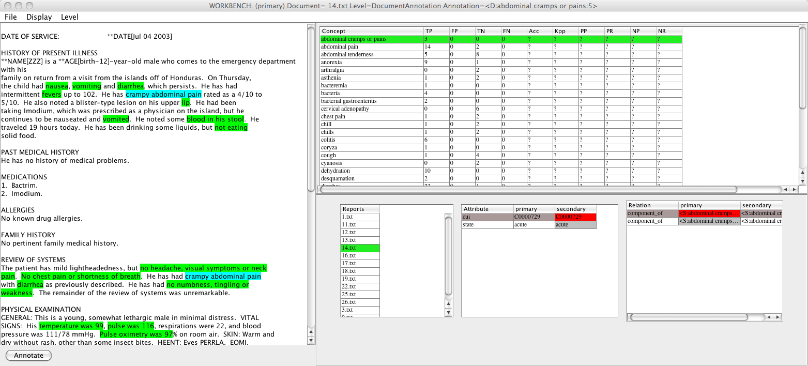

Document Panel:

Annotations are displayed in color in this panel. The selected annotation is displayed in cyan, and unselected annotations are displayed in a color indicating the current level. (Currently there are just two colors: Green for Document level, and Yellow for Snippet level.) You can select annotations by moving the mouse over segments of the document. The classification, attributes and relations of the selected annotation are updated automatically in the class/statistics, attribute and relation panels.

Class/statistics Panel:

The first column displays classifications for the currently selected level, in alphabetical order. When you move the mouse over a classification name, an annotation having that classification is selected, and the document, attribute and relation panels are correspondingly updated. (At the Document level, this selects the unique Document-level annotation for that classification. At lower levels, it selects just one of possibly multiple annotations.)

Columns to the right of the classification name indicate True Positive (etc) as well as statistics such as Kappa, Precision and Recall. (Note: Although the statistics infrastructure is written, there are some bugs in the calculations, so the tool currently displays “?” for these measures.)

click on an annotation→
<label with binary values visualization>  OMs for classifications of annotation at the snippet level. The highlighted annotation will be highlighted in the statics pane to stand out from other annotations OMs. |  | diagram of schema with that annotation highlighted
Report that is being shown | Attributes of annotation | Relations of annotation

hover over an annotation→
<label with binary values visualization>  OMs for classification of that annotation at the active level. If you switch levels, the OMs for the classification of the highlighted level will switch to the new active level. |  | diagram of schema with that annotation highlighted
Report that is being shown | Attributes of annotation | Relations of annotation

Attribute Panel:

Displays lists of attributes/values attached to the currently selected annotation.

(Odd design decision alert: ) There are two value columns. Oddly, both show the same value, but this gives a way to easily move between annotation sets for the first and second annotator (I know there must be a better way). Moving the mouse between columns selects the first or second annotator as the currently selected annotator, and correspondingly displays the different annotation sets.

Clicking the mouse on a value displays a pulldown menu containing all known values for an attribute. You can’t change the assigned value this way, but it allows you to see the possible values.

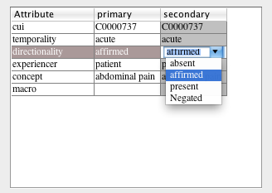

hover over an attribute (or click on that attribute in the schema pane)→
attribute name:
OMs for that attribute in the corpus–  binary values- <label with binary values>, no extra tab;  multiple values- <label with multiple values>: label with each value is the default, tab for label with one versus all. |  | diagram of schema with that attribute highlighted
Report that is being shown | Attributes of annotation | Relations of annotation

Relation Panel:

Displays relations owned by the selected annotation. The relatum name is a string denoting the level, classification and unique annotation id (e.g. “<S(nippet):abdominal cramps or pains:29>”). When you move the mouse over a related annotation, that annotation becomes the current selection. For instance, selecting one of the “component-of” relata of a Document annotation will select one of its Snippet annotations, that Snippet will appear selected in the Document panel, and the Snippet’s classification will be highlighted in the class/statistics pane. That Snippet in turn has a single “parent_of” relation referring back to the parent Document level annotation. Moving the mouse back and forth in this panel is a way to quickly select between parent and child annotations.

From Document-level annotation:
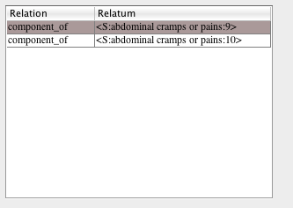

From Snippet-level annotation:

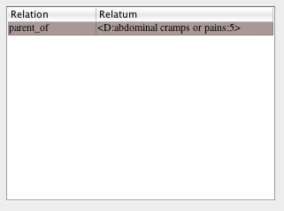

Schema Panel:
Graph representing the annotation schema (like mindmap?) or html rendition. The annotation being viewed (and whose outcome measures are being shown) will be highlighted. Can we also use this to select compound label evaluations?

Outcome measures for compound label classifications:

Classification + Classification –-> cui classification + semantic type classification
Attribute + Attribute –-> certainty + negation
Classification + attribute → cui classification + negation

If attribute has binary values:

 | Primary assigned Classification and attribute value to span | Primary did not assign Classification and attribute value to span
Secondary assigned Classification and attribute value to span | TP | FP
Secondary not assign Classification and attribute value to span | FN | TN

In spreadsheet visualization:

 | TP | FP | TN | FN
Class1+attribute_val1
Class1+attribute_val2 (this can be optional – is helpful, but not everyone will want)
Classn+attribute_val1
Classn+attribute_val2

If attribute has multiple values: (eg cui + certainty)

For each combination of classification + valuei
 | Primary assigned classification_{i} and attribute value_{j} to annotation | Primary did not assign classification_{i} and attribute value_{j} to span
Secondary assigned classification_{i} and attribute value_{j} to span | TP | FP
Secondary not assign classification_{i} and attribute value_{j} to span | FN | TN

In spreadsheet visualization:

One versus rest (two rows for each classification value):
 | TP | FP | TN | FN
Classi+attribute_valj
Classi+not attribute_valj

Each value:
 | TP | FP | TN | FN
Classi+attribute_val1
Classi+attribute_val2
…
Classi+attribute_valn

Highlighted annotations during compound label classifications—what should be highlighted in the document pane? I guess instances that match the query in the same way as the rest of the cases is.

